Sample questions for pulmonary, renal and acid-base:

- The following is a list of major divisions of the airways.

            - secondary bronchus
            - bronchioles
            - alveoli
            - primary bronchus
            - respiratory bronchiole
            - terminal bronchiole

The order in which air passes through the airways during inspiration is:
  - 4,1,2,6,5,3
  - 4,1,5,6,1,3
  - 1,4,2,5,6,3
  - 1,4,5,2,6,3
  - 4,1,6,5,2,3

- Total lung capacity is equal to:

  - expiratory reserve volume + forced vital capacity
  - inspiratory reserve volume + tidal volume
  - vital capacity + residual volume
  - tidal volume + residual volume
  - inspiratory reserve volume + expiratory reserve volume

- According to Fick’s law of diffusion, which of the following changes would decrease the rate of diffusion of a gas across an exchange surface? (for each answer, assume other factors are held constant)

  - decrease in molecular weight of the gas
  - increase in the surface area of exchange
  - increase in the pressure gradient
  - increase in the solubility coefficient of the gas
  - increase in thickness of the exchange surface

- Which of the following is transported INTO red blood cells as bicarbonate is transported out via a counter-transport mechanism?

  - carbon dioxide
  - hydrogen
  - oxygen
  - chloride
  - water

- For the figure below, which of the following statements is most accurate regarding the oxyhemaglobin curves shown?
- 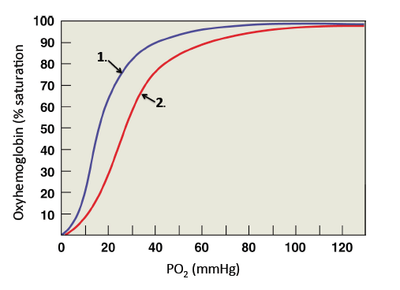
  - the P50 for hemoglobin is higher for curve 2 compared to curve 1
  - the affinity of hemoglobin for oxygen is higher in curve 2 compared to curve 1
  - curve 2 represents oxyhemoglobin at a lower temperature than curve 1
  - curve 2 represents oxyhemoglobin in the presence of carbon monoxide compared to curve 1 in the absence of carbon monoxide
  - A and B

- Given the following data, calculate the alveolar ventilation: (you may not need all values)
      - Respiratory frequency = 17 breaths/minute
      - Physiological dead space = 150 mL
      - Inspiratory reserve volume = 1000 mL
      - Tidal volume = 550 mL

  - 400 mL/min
  - 6800 mL/min
  - 9350 mL/min
  - 14,450 mL/min
  - cannot be calculated from data provided

- Which of the following would NOT be a physiological effect resulting from exposure to high altitude (either immediate or long term):

  - acidosis
  - hypoxemia
  - increased production of red blood cells
  - hemoglobin with a decreased affinity for O₂
  - tachycardia

- Which is TRUE of the ventral respiratory group (VRG)?

  - it controls accessory motor neurons of exhalation
  - it controls accessory motor neurons of inhalation
  - it functions in every respiratory cycle
  - A and B
  - A, B, and C

- The central chemoreceptors located in the medulla oblongata are stimulated by:

  - H+ ions that diffuse across the blood brain barrier
  - H+ ions generated from carbonic acid production as CO₂ diffuses across blood brain barrier
  - CO₂ directly
  - O₂ directly
  - all of the above

- Be sure you know the location and function of everything in these diagrams.

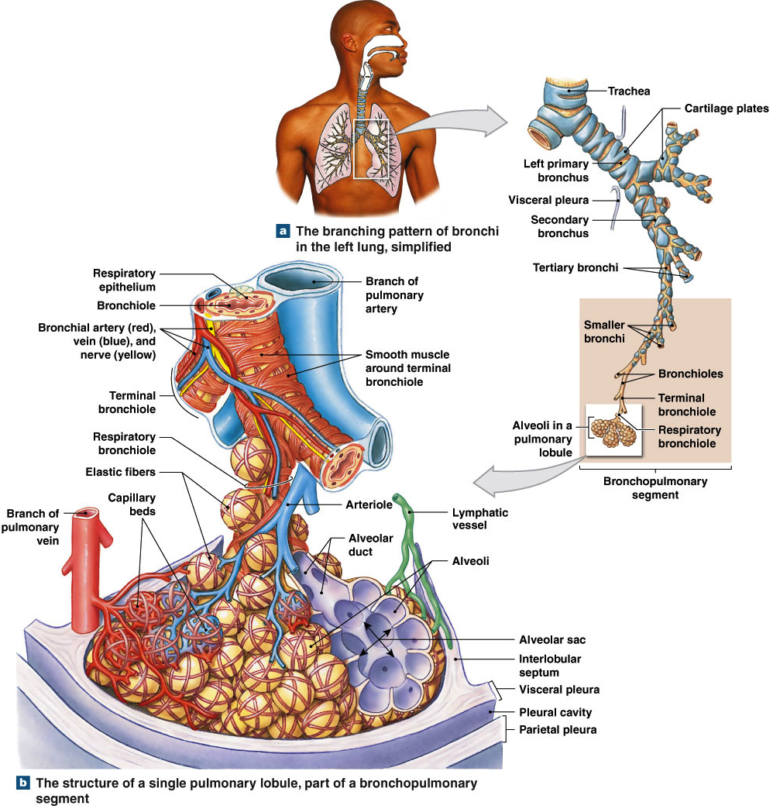

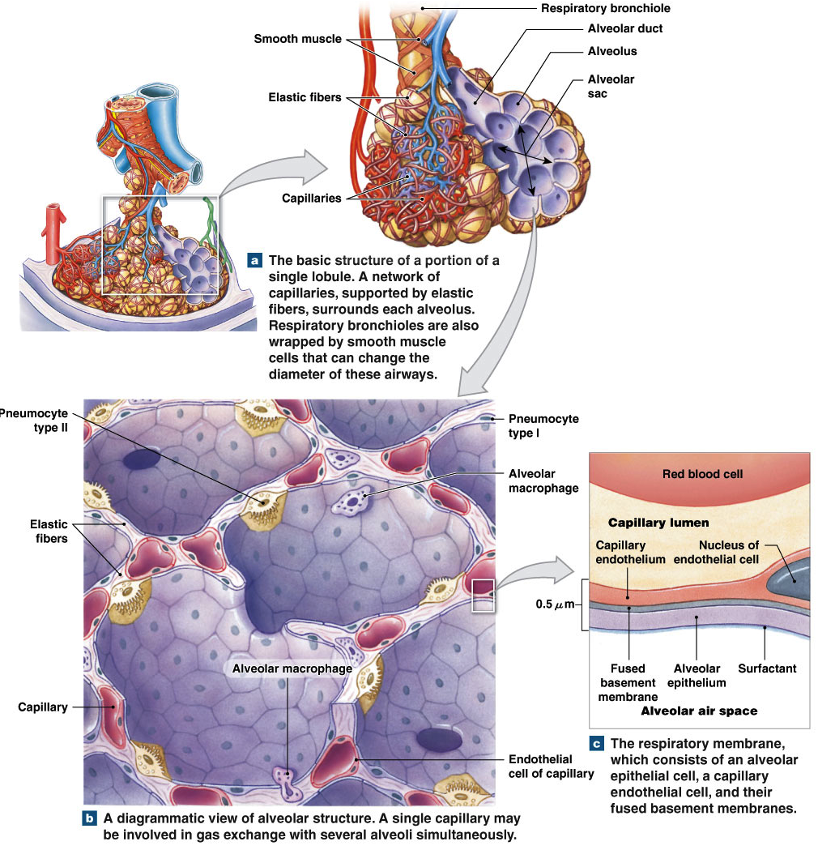

- Which of the following is NOT a normal function of the kidneys?

  - stabilizing blood pH
  - production of erythropoietin
  - secretion of glucose
  - excretion of toxins and metabolic wastes
  - regulation of body fluid volume

- Using the figure below, select the answer that correctly identifies the selected numbered structures.

- 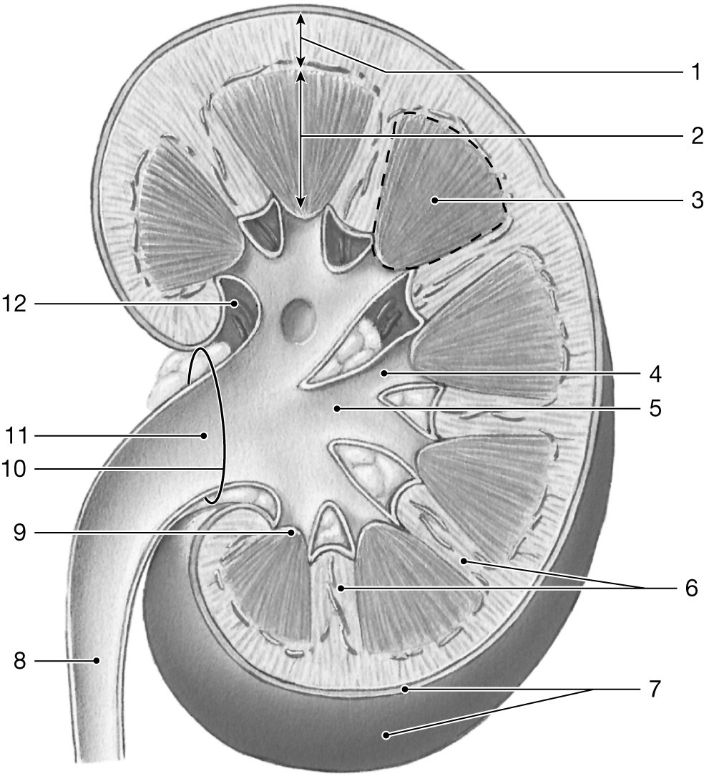

  - 1. Renal cortex ; 3. Renal pyramid; 4. Minor calyx; 9. Renal hilum
  - 1. Fibrous capsule; 3. Renal cortex; 4. Renal pelvis; 9. Renal papilla
  - 1. Renal cortex ; 3. Renal Pyramid ; 4. Minor calyx ; 9. Renal papilla
  - 1. Collecting Ducts; 3. Renal papilla; 4. Renal Sinus; 9. Major Calyx
  - 1. Renal medulla; 3. Renal Cortex; 4. Major calyx; 9. Renal papilla

- Which of the following statements about the kidney is most accurate?

  - The majority of sodium and water reabsorption occurs in the PCT of the nephron
  - The majority of glomeruli are located in the renal medulla
  - The majority of water filtered by the glomerulus will be excreted as urine
  - The renal pelvis drains into the common collecting duct
  - The kidneys receive approximately 1 % of cardiac output

- Which of the following situations would tend to DECREASE glomerular filtration rate (GFR)?

  - an increase in atrial natriuretic peptide
  - an obstruction of the ureter, which would increase capsular hydrostatic pressure (CsHP)
  - vasodilation of the afferent arteriole
  - A and B
  - A, B, and C

- Which of the following statements about the glomerular filtration barrier is most accurate?

  - urea can pass through the filtration barrier
  - plasma proteins can pass through the filtration barrier
  - glomerular capillaries are permeable to red blood cells
  - the filtration barrier is not permeable to positively charged ions
  - the glomerulus is comprised of sinusoidal capillaries

- Which of the following would increase potassium secretion by Principal cells located in the distal part of the nephron?

  - increased sodium absorption across epithelial sodium channels (ENaCs)
  - overproduction of aldosterone
  - increased delivery of sodium to the distal part of the nephron
  - A and B
  - A, B, and C

- Choose the correct answer that describes the following sentence: The thick ascending limb of the loop of Henle is 1) highly permeable to water 2) reabsorbs sodium, potassium and chloride ions from the filtrate and 3) dilutes the tubular fluid.

  - the first statement (1) is true; the second statement (2) is false; the third statement (3) is true
  - the first statement (1) is false; the second statement (2) is true; the third statement (3) is true
  - the first statement (1) is true and the second statement (2) is true; the third statement (3) is false
  - the first statement (1) is false; the second statement (2) is true; the third statement (3) is false
  - all statements (1,2,and 3) are true

- The tubular fluid that enters the proximal tubule has an approximate osmolarity of _________and the tubular fluid leaving the proximal tubule has an approximate osmolarity of ____________.

  - 300 mOsm; 1200 mOsm
  - 150 mOsm; 300 mOsm
  - 600 mOsm; 150 mOsm
  - 300 mOsm; 300 mOsm
  - 150 mOsm; 150 mOsm

- ADH is released from _____________ in response to a(an) ________________in plasma osmolarity.

  - posterior pituitary; decrease
  - juxtaglomerular cells; decrease
  - posterior pituitary; increase
  - juxtaglomerular cells; increase
  - macula densa cells; decrease

- A patient has PCO2 of 61 mmHg, blood HCO3- of 26 mM, what is the pH? (pKa of HCO3- is 6.1)
  - 7.10
  - 7.25
  - 7.35
  - 7.45
  - 7.60

- The patient above has:
  - Compensated respiratory alkalosis
  - Uncompensated respiratory acidosis
  - Compensated respiratory acidosis
  - Compensated metabolic alkalosis
  - Uncompensated metabolic acidosis

- For questions (25)) choose the letter on the diagram below.
(NOTE: BE is base excess, which we didn’t cover in class – the farther BE is from 0 then the greater the metabolic compensation or disturbance.)

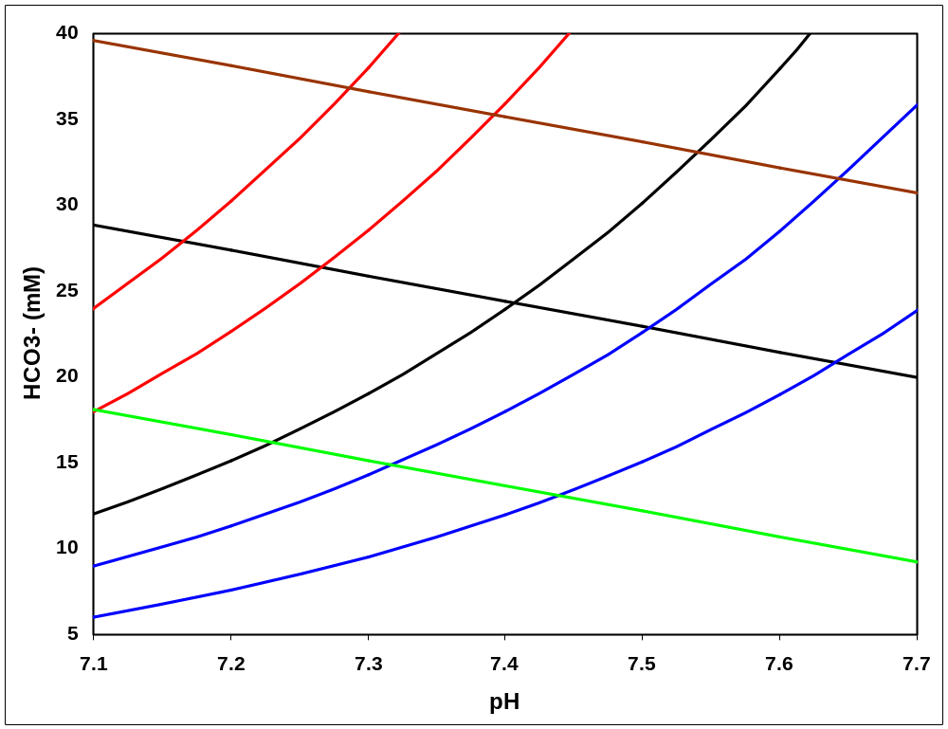
80 mmHg
60 mmHg
40 mmHg
30 mmHg
20 mmHg
BE = 0
BE = 10
BE = -10
B
A
C
D
E

- Renal tubular acidosis resulting in loss of bicarb

